RESPONNSIVE PORTFOLIO WEBSITE

DOCUMENTATION

Internship: Frontend Developer Intern at ALFIDO TECH

TASK: Task 1 – Reponsive Portfolio Website

Developed By: Srimanthula Asmitha

Technology Used: HTML5, CSS3, Bootstrap 5,javascript

Hosting Platform: https://srimanthulaasmitha.github.io/ALFIDO-TECH-TASK1/

Source Code Repository: https://github.com/SrimanthulaAsmitha/ALFIDO-TECH-TASK1

Project Title

Responsive Personal Portfolio Website- A fully responsive personal website designed to showcase my profile, technical skills, projects, and contact information.

Objective

The objective of this project is to create a professional and visually appealing portfolio website that represents my academic background, technical skills, and project work.The website is mobile-friendly and adapts seamlessly across desktop, tablet, and smartphone devices.

Project Description

This portfolio website serves as my personal online presence. It allows visitors, recruiters, and internship evaluators to learn about me and explore my work.
The website includes the following sections:
Home Section -Introduction and profile summary.
Skills Section – Programming languages and technologies.
Projects Section – Featured academic and personal projects.
Contact Section – Social media links and phone number.
The design is inspired by modern portfolio websites and uses a dark theme with neon green highlights to create an attractive and professional appearance.

Features

- Fully responsive design.
- Fixed navigation bar with smooth scrolling.
- Animated hero section.
- Glowing profile image.
- Interactive skill cards.
- Project cards with GitHub and live demo links.
- Social media icons for LinkedIn, Gmail, GitHub, and Instagram.
- Click-to-call phone number.
- Hosted online using GitHub Pages.

Technologies Used
Technology Purpose:
HTML5 Structure of the website
CSS3 Styling and animations
Bootstrap 5 Responsive layout and components
JavaScript Bootstrap interactivity
Google Fonts Typography
Bootstrap Icons Social media icons
Git & GitHub Version control and source code hosting
GitHub Pages Live Deployment

Project Structure

Portfolio – Website/
|---Index.html
|---Style.css
|---profile.JPEG
|---cv.JPEG
|---README.md

SCREENSHORTS

1: HOME SECTION
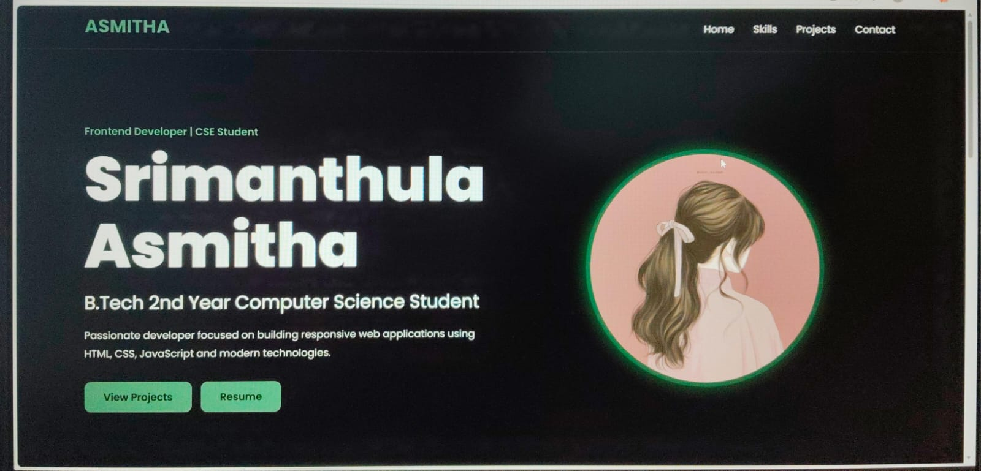

2:SKILL SECTION
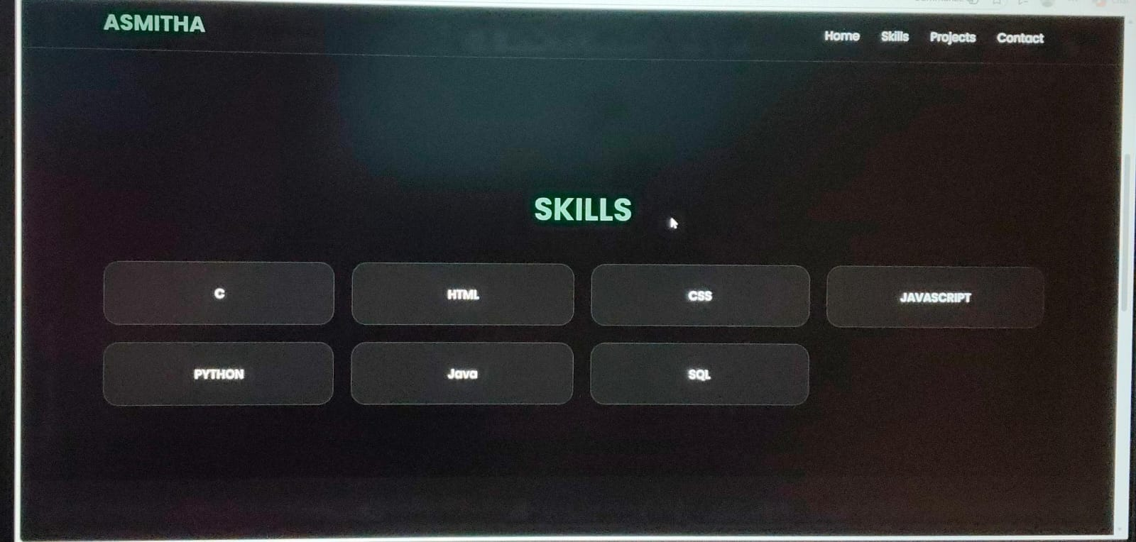

3:PROJECT SECTION
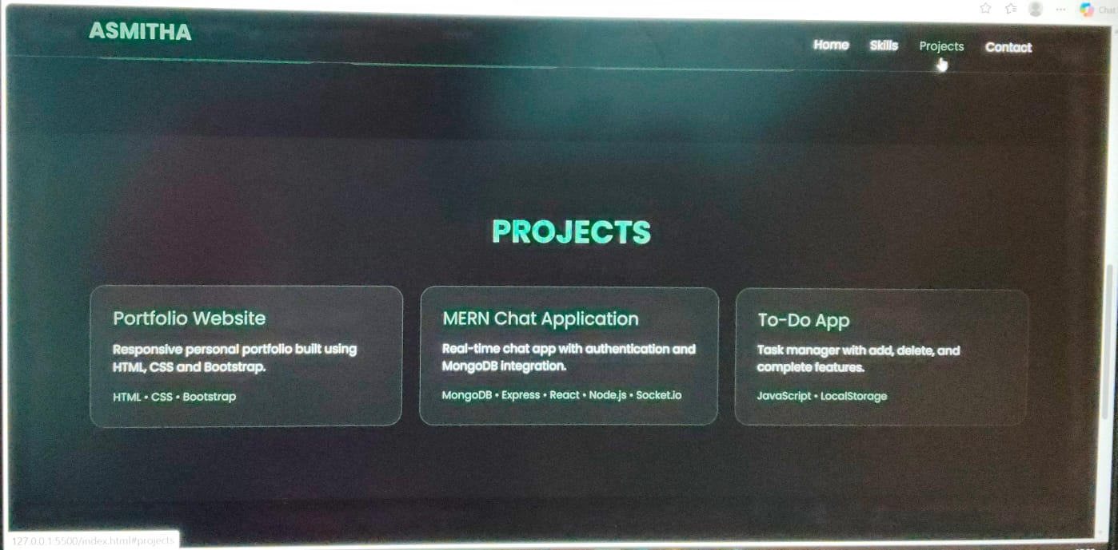

4:CONTACT SECTION
